

**TRAFFIC**

**Pedestrians do not have the right-of-way in the shipyard and must yield to all vehicle and crane movement.**

**BEWARE OF CRANE MOVEMENT AND SUSPENDED LOADS. No one shall travel under a suspended load and should keep a safe distance away. For example, if the load is 25 feet in the air, your distance away from the load should also equal 25 feet. All persons must remain back from suspended loads and take direction from the attending riggers (in yellow helmets).**

**DO NOT CROSS THE RAILROAD TRACKS IN THE STEEL YARD WHILE GATE 12 IS OPEN FOR THE BNSF TRAIN. It may take as long as 20 minutes. You may not cross either side of the yellow line until the gate is closed and the horn is silenced.**

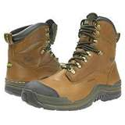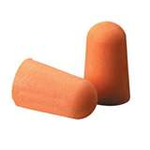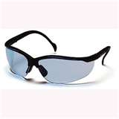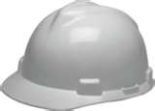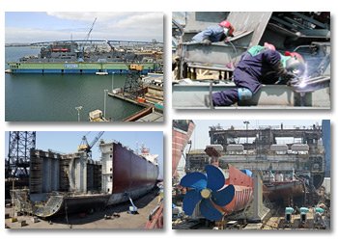

**EMERGENCY NUMBERS**

**Incident Type Landline Cell Phone**

**Fire or Medical 911 619-544-8777**

**Spill Reporting x8401 619-544-8401**

**GENERAL INFORMATION NUMBERS**

**Information Type Landline Cell Phone**

**Environmental x7506 619-544-7506**

**Fire Department x8889 619-544-8889**

**Maintenance x8666 619-544-8666**

**Medical x8861 619-544-8861**

**Safety x8444 619-544-8444**

**Security x8401 619-544-8401**

**The speed limit in the yard is 5 mph. All vehicles movement stops for ten minutes at 3:00 p.m. and at 12:30 a.m. for shift change.**

**There is no running the yard.**

NASSCO production

facilities include its shipyard at

28th Street and Harbor Drive, plus certain other building and facilities located in the surrounding area. NASSCO designs, builds, and repairs both military and commercial ships.

For your safety, NASSCO requires that everyone entering the shipyard or other production locations wears the minimum Personal Protective Equipment (PPE) identified in this brochure.

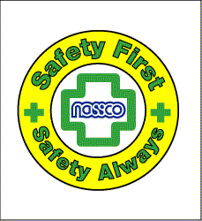

**Safety -**We ensure a safe workplace for all.

2798 East Harbor Drive

San Diego, CA 92113

www.nassco.com

CLOTHING

The minimum clothing requirements while visiting or transiting the shipyard are:

* Shirts/Blouses
  + Must cover the entire torso;
  + Must have at least short sleeves. (Tank tops and sleeveless shirts are not permitted.)
* Trousers/Pants must be full length with no portion of the leg exposed.
* Skirts/Dresses as business appropriate and only while transiting between offices.

FOOT PROTECTION

All persons entering the shipyard must wear sturdy all-leather shoes or boots that cover the entire foot and have a well defined heel. The heel must be at least ¼” and no more than 1¾”. It is prohibited to wear tennis shoes, sneakers, shoes with uppers containing any man-made material, cloth shoes, light-weight leather shoes, and high-heeled shoes in the shipyard. Open-toe shoes, sandals, and slipper-type footwear may not be worn in the shipyard at any time.

Welcome to General Dynamics National Steel and Shipbuilding Company (NASSCO). To ensure a safe and enjoyable visit to our facility, we ask that you review the safety information contained in this brochure. If you have any questions, please ask your sponsor or contact the NASSCO Safety office at 619 544-8444.

Visitors & Vendors

When arriving at nassco the folloWing Will be provided:

* Hard hats
* safety glasses
* hearing protecton

**CONTRACTORS are required to provide their own hard hats, safety glasses, hearing protection and other required PPE.**



Minimum PPE for transiting the shipyard

HEAD PROTECTION

Hard hats must be worn in all production areas. Hard hats must meet the ANSI Z89.1 Standard, be fire retardant, and not conduct electricity. (Cowboy-type hard hats are not allowed.)

EYE PROTECTION

Only safety glasses that meet the ANSI Z87.1 standard are acceptable and must be worn at all times in the shipyard. Dark lenses that hide the eyes are not allowed on board any vessel. DO NOT STARE AT ANY WELDING ARC since prolonged exposure can cause injury to your eyes.

HEARING PROTECTION

Hearing must be protected at all times by wearing suitable ear plugs or ear muffs in noise hazard areas. The blast cells at the south end of the yard require double hearing protection.

Basic Safety Requirements

We ensure a safe workplace for All.