# NASSCONewlogo

# CARRIER ROUTING GUIDE

**Revised 10/03/13**

The following pages are for shipments consigned to General Dynamics NASSCO, San Diego, CA. These Routing Guide Instructions are considered an adjunct to the Packing and Shipment requirements of NASSCO’s Purchase Order Terms and Conditions. ***Excess freight costs incurred due to noncompliance with these instructions and the instructions on the face of the NASSCO Purchase Order shall result in these extra costs being backcharged to the supplier per the provisions of NASSCO’s Purchase Order Terms and Conditions unless authorized by the NASSCO buyer prior to shipment*.** The normal transportation mode will be via surface carriers. Only the NASSCO buyer will authorize premium transportation, which includes airfreight, air express, padded van and exclusive use of truckload or carload carrier. To the extent possible where such shipment still supports NASSCO production requirements, NASSCO will work with the Seller to consolidate multiple shipments from the same origin/location.

Delivering Warehouse Locations:

* 8511 Kerns St., San Diego, CA 92154 receiving hours from 06:30 AM to 02:30 PM
* 2798 Harbor Dr., Annex 43w Gate #14 receiving hours from 06:30 AM to 02:30 PM

**Marking Requirements**

Each container will have markings with a contrasting color to the container with the following information: 1. PO, Number, 2. Part number, 3. Part Quantity, 4. Carton number, 5. Total cartons. These markings must be placed in such a manner that opening the container does not destroy any of the information. They must also be legible and not interfere with any special handling labels.

# 

# Consignee

##### PO Number

**Part Number**

**Part Quantity**

**Carton #**

**Total Cartons**

# Address &

# Attention Markings

**Shipping Paper Requirements**

The shipping invoice must contain the NASSCO purchase order(s) or job number. **The air waybill or bill of lading must include the NASSCO *purchase order(s) or job number*.**

**COD SHIPMENTS WILL NOT BE ACCEPTED**. NASSCO reserves the right to annotate all carrier bills of lading to document discrepancies and shortages.

##### ABC Freight Company

Date\_\_\_\_\_\_\_\_\_\_\_\_\_\_\_ Pro. No.\_\_\_\_\_\_\_\_\_\_\_\_\_\_\_\_\_\_

B/L No\_\_\_\_\_\_\_\_\_\_\_\_\_\_Page No.\_\_\_\_\_\_\_\_\_\_\_

Shipper Name National Steel & Shipbuilding Company a General Dynamics Co.

**NASSCO**

**Address 1699 MAIN STREET**

**SIGSBEE STREET RECEIVING**

**City State Zip Code Destination City State Zip Code**

**SAN DIEGO, CA. 92113**

**INVOICEE CUSTOMER PO NUMBER (NASSCO PO Number is Required)**

**ADDRESS SPECIAL INSTRUCTIONS**

**PREPAID COLLECT**

# Shipments to General Dynamics NASSCO San Diego, California or to an

# Authorized Supplier, freight paid by NASSCO

## SURFACE SHIPMENTS

|  |  |  |
| --- | --- | --- |
| 0-150 lb. | Small package Ground service which are within the FedEx dimensional sizes | FedEx Ground, if using hundred weight follow FedEx guidelines Do not use FedEx First overnight unless shipment needed before 08:00 AM |
| 150-10,000 lb. | Single and multiple package shipments exceeding the small package requirements by common carrier | See the carriers on the “ LTL Freight  Carrier Listing”. |
| >10,000 lb., or >1,000 cu. ft. or  > 20 ft. long | Contact Logistics, provide the weight, dimensions freight description and PO Number | Patricia Carrillo  PH: (619) 744-1459  Cell (619) 876-9751; or  Juan Carrillo  Cell (619) 890-1601  Fax (619) 544-3482 |



### Domestic AIR SHIPMENTS

**Note: Second Day Service if PO delivery date permits;**

**Overnight Air Express if PO delivery requires**.

|  |  |  |
| --- | --- | --- |
| 1-150 lb. | Small package shipments requiring **overnight** service purchased F.O.B. freight collect with the 50 states | Federal Express |
| 150-500 lb. | Small package shipments requiring **overnight** service purchased F.O.B. freight collect within the 50 states | Crane Worldwide or CH Robinson |
| > 501 lb. | Contact, Logistics, provide the weight, dimensions freight description and PO Number | Patricia Carrillo  PH: (619) 744-1459  Cell (619) 876-9751; or  Juan Carrillo  Cell (619) 890-1601  Fax (619) 544-3482 |

**ACCOUNT CONTACTS**

|  |  |  |  |  |
| --- | --- | --- | --- | --- |
|  | **Account Number** | **Customer Service Phone** | **Web Site** | **General Dynamics NASSCO Account Manager** |
| **Crane Worldwide** | GENE798ATL | (310) 765 2303 | [www.craneww.com](http://www.craneww.com) | Sheena Mariano  (424) 225-4200 M  (310) 765-2303 O |
| **Federal Express** | Contact NASSCO for Account Number **Not the carrier** | 800-463-3339 (GO FEDEX) | [www.fedex.com](http://www.fedex.com) | Olivia Waites  (770) 814-2681 |

### International AIR SHIPMENTS

|  |  |  |
| --- | --- | --- |
| 1-150 lb. | Small package shipments requiring **express** service purchased Ex Works freight collect from foreign country | **DHL Express For Account number consult NASSCO** |
| > 501 lb. | Contact, Logistics, provide the weight, dimensions, freight description and PO Number | Patricia Carrillo  PH: (619) 744-1459  Cell (619) 876-9751; or  Juan Carrillo  Cell (619) 890-1601  Fax (619) 544-3482 |

**ACCOUNT CONTACTS**

|  |  |  |  |  |
| --- | --- | --- | --- | --- |
|  | **Account Number** | **Customer Service Phone** | **Web Site** | **General Dynamics NASSCO Account Manager** |
| **DHLEXPRESS** | Contact NASSCO for  International AccountNo.  **Not the carrier** | (877) 873-2521 Key Accounts | [www.dhl.com](file:///C:\Users\N60318\AppData\Local\Microsoft\Windows\Temporary%20Internet%20Files\Content.Outlook\B0MDHAE4\www.dhl.com) | David Fields (928) 222-5359 |
| DHL Global | Bill Recipient on Collect No account number |  | [www.dhl-dgf.com](http://www.dhl-dgf.com/) | David Caceres  (858) 610-8269 |
| **Crane Worldwide** | GENE798ATL | (310) 765-2303 | [www.craneww.com](http://www.craneww.com) | Sheena Mariano  (424) 225-4200 M  (310) 765-2303 O |
| Panalpina | Bill Recipient on Collect No account number | (619) 671-2010 | [www.panalpina.com](http://www.panalpina.com) | Jim Burritt  (619) 210-2112 |

**Drop shipments within the United States**

##### Third Party Billed to NASSCO

##### LTL SHIPMENTS UNDER 10,000 LBS

|  |  |  |
| --- | --- | --- |
| **Intrastate California** | Preferred Carrier |  |
| **Within California** | Reddaway Freight | UPS Freight |

**LTL CARRIER ACCOUNT CONTACTS**

|  |  |  |  |  |
| --- | --- | --- | --- | --- |
|  | **Account Number** | **Customer Service Phone** | **Web Site** | **General Dynamics NASSCO Account Manager** |
| **Conway** | Contact NASSCO for Account Number **Not the carrier** | 800-755-2728 | <https://www.con-way.com> | Ken Kaelin  1-866-809-4604 |
| **Reddaway** | Bill Recipient on Collect No account number | 888-420-8960 | [www.reddawayregional.com](http://www.reddawayregional.com) | Chris Lines  (858) 229-8030 |
| **UPS Freight** | Bill Recipient on Collect No account number | 800-333-7400 | [www.ltl.upsfreight.com](http://www.ltl.upsfreight.com) | Jannika Baca (858) 210-1114 |
| **Yellow YRC Freight** | Bill Recipient on Collect No account number | 800-610-6500 | [www.yrc.com](http://www.yrc.com) | Patrick Rocco  (858) 967-4654 |

**TRUCKLOAD CARRIER CONTACTS**

|  |  |  |  |  |  |  |  |
| --- | --- | --- | --- | --- | --- | --- | --- |
| **Carrier Name** | **Account Number** | | **Customer Service Phone** | | **Web Site** | | **General Dynamics NASSCO Account Manager** |
| **ATS Logistics**  **Anderson Trucking** | No Account Number | | 888-274-1829 | | [www.ats-sureway.com/index.jsp](http://www.ats-sureway.com/index.jsp) | | Kim Cooper  888-274-1829 |
| **Landstar Ranger** | No Account Number | | (520)721-6270 | | [www.landstar.com/Landstar/default.aspx](http://www.landstar.com/Landstar/default.aspx) | | Chip /Garith Warner  800-552-5976 |
| **Robert Bare Associates** | No Account Number | | 800-344-4491 | | [www.robertbareassociates.com](http://www.robertbareassociates.com) | | Mike Houston 800-919-9390 |
| **C. H. Robinson Worldwide** | | No Account Number | | (810) 225-4675 | | [www.chrobinson.com](http://www.chrobinson.com) | Rick Merritt  Jason Woods  (810) 225-4675 |

****

### Requirements for International Shipments

1. **Documentation.** The following documents must be forwarded in an electronic version acceptable to NASSCO and the Customs Broker at the time of shipment

* Commercial Invoice
* Packing List
* Original/Copy Bill of Lading
* Certificate of Origin (NAFTA, UKFTA If applicable)
* Repair certificate (if applicable)
* Antidumping/Countervailing Duty case number (If applicable)
* Instrument of International Traffic (IIT) if applicable

1. **Document to be sent to:**

* Patricia Carrillo **(**[patricia.carrillo@nassco.com](mailto:patricia.carrillo@nassco.com))
* Gene McClellan ([Eugene.mcclellan@nassco.com](mailto:Eugene.mcclellan@nassco.com))
* Panalpina ([brokerage.san@panalpina.com](mailto:brokerage.san@panalpina.com))

1. **Commercial Invoice/Packing List.** The following data elements must be included on the commercial invoice and, if checked here specified below, the data elements provided herein must be utilized. All reusable containers suitable for repetitive use must be separately declared (i.e., classified and valued) on commercial invoices and Customs entries. If properly qualified, Instruments of International Traffic or substantial containers may be exempt from formal entry requirements or classified under HTSUS subheading 9803.00.50 depending on their character and use. IIT require a customs bond and must be tracked, properly manifested and entered when appropriate.

* Invoice Date
* Complete name and address of the shipper/seller as shown on the NASSCO

Purchase Order

* Port of U.S. Entry
* Purchase Order Number
* Invoice currency:
* Terms of Sale & location of Title Transfer
* Incoterms:
* The following information must be provided for each part. If multiple part numbers with different individual details are contained on a single Purchase Order.
  + Part number(s): (NASSCO)
  + Serial Number (if applicable):
  + Detailed description of the part and use (material(s), specifications, how it works, what it is used in, etc.) (Attach drawings/pictures/specs)
  + HTSUS Classification/Rate of Duty: \_\_\_\_\_\_\_\_\_\_\_\_\_\_\_\_\_\_\_\_\_\_\_\_\_\_\_\_\_\_\_\_\_\_\_
    - Does the part qualify for a special duty program? (9801/9802/GSP/CBI/Free Trade Agreements)? □ Yes □ No
    - If yes, supply copy of special duty program qualification documentation.
    - Attach verification analysis.
  + HTSUS reporting quantities:\_\_\_\_\_\_\_\_\_\_\_\_\_\_\_\_\_\_\_\_\_\_\_\_\_\_\_\_\_\_\_\_\_\_\_\_\_\_\_\_\_
  + Quantity in individual units:\_\_\_\_\_\_\_\_\_\_\_\_\_\_\_\_\_\_\_\_\_\_\_\_\_\_\_\_\_\_\_\_\_\_\_\_\_\_\_\_\_
  + Gross weights in kilograms:\_\_\_\_\_\_\_\_\_\_\_\_\_ Net weight in kilograms:\_\_\_\_\_\_
  + Individual Unit Customs Value:\_\_\_\_\_\_\_\_\_\_\_\_\_\_\_\_\_\_\_\_\_\_\_\_\_\_\_\_\_\_\_\_\_\_\_\_\_\_
  + Extended value (Quantity Individual Unit Value):\_\_\_\_\_\_\_\_\_\_\_\_\_\_\_\_\_\_\_\_\_\_\_
  + Additions to the unit price of the goods (tools, molds, equipment, merchandise used to make finished product, supplied at no charge) (Overseas Engineering) (Royalties) (Milestone progress payments/Other payments)
  + No charge shipment value (contact planning for standards)
  + Deductions from the unit price of the goods:\_\_\_\_\_\_\_\_\_\_\_\_\_\_\_\_\_\_\_\_\_\_\_
  + Country of origin:\_\_\_\_\_\_\_\_\_\_\_\_\_\_\_\_\_\_\_\_\_\_\_\_\_\_\_\_\_\_\_\_\_\_\_\_\_\_\_\_\_\_\_\_\_\_\_\_\_\_
  + Name of responsible employee with contact information of exporter who has knowledge of this transaction:\_\_\_\_\_\_\_\_\_\_\_\_\_\_\_\_\_\_\_\_\_\_\_\_\_\_\_\_\_\_\_\_\_\_\_\_\_\_

1. **Marking – Country of Origin.**
2. **Antidumping/Countervailing Duty.**
   * Is the product(s) subject to antidumping or countervailing duty □ Yes □ No
   * What is the case number? (A\_\_\_\_\_\_\_ \_\_\_\_\_\_\_ \_\_\_\_\_\_\_, or C\_\_\_\_\_\_\_ \_\_\_\_\_\_\_ \_\_\_\_\_\_\_)
   * What is the Manufacturer Name/MID#?\_\_\_\_\_\_\_\_\_\_\_\_\_\_\_\_\_\_\_\_\_\_\_\_\_\_\_\_\_\_\_\_\_\_\_\_\_\_
   * What is the Manufacturers AD/CVD case number?\_\_\_\_\_\_\_\_\_\_\_\_\_\_\_\_\_\_\_\_\_\_\_\_\_\_\_\_
   * What is the assigned Rate of AD/CVD for the manufacturer?
   * Is it subject to Bond at the time of entry? □ Yes □ No
   * Is cash payment required at the time of entry? □ Yes □ No
   * Are you to be reimbursed by the seller/manufacturer for any antidumping duty liability?

□ Yes □ No

( If the answer is “yes,” advise CBP and make the declaration at time of entry.)

* + Prepare a Blanket Statement of Non-Reimbursement Statement for Antidumping and present to CBP at time of entry.

1. **Advanced Shipment Security Information Profile “10+2” Required Per Vendor Plant and Shipping Channel.\* (carriers, cargo configurations, and invoices) should be provided by shipper at least 72 hours prior to lading for Ocean-going shipments, and 24 hours prior to shipment via Air or Land.**
2. **Wood Packing Material requirements for Import shipments to the United States (USCBP/USDA).**

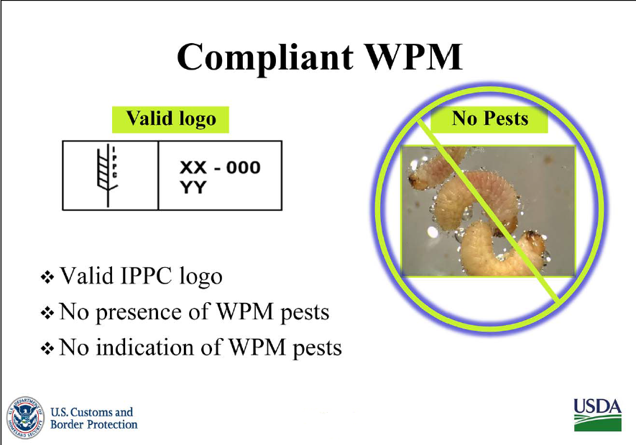

This standard describes phytosanitary measures that reduce the risk of introduction and spread of quarantine pests associated with the movement in international trade of wood packaging material made from raw wood. Wood packaging material covered by this standard includes dunnage but excludes wood packaging made from wood processed in such a way that it is free from pests (e.g. plywood).

Approved phytosanitary measures that significantly reduce the risk of pest introduction and spread via wood packaging material consist of the use of debarked wood (with a specified tolerance for remaining bark) and the application of approved treatments (as prescribed in Annex 1). The application of the recognized mark (as prescribed in Annex 2) ensures that wood packaging material subjected to the approved treatments is readily identifiable. The approved treatments, the mark and its use are described.

ISPM 15 is the International Standards for Phytosanitary Measures Publication No. 15- Guidelines for Regulating Wood Packaging in International Trade. It represents the first international commodity based standard and sets out criteria for regulating wood packaging material used in international trade.

Reference for Wood Packaging Material (WPM) from USCBP and USDA: <http://www.cbp.gov/linkhandler/cgov/trade/trade_outreach/wood_packaging_pp.ctt/wood_packaging_pp.pdf>

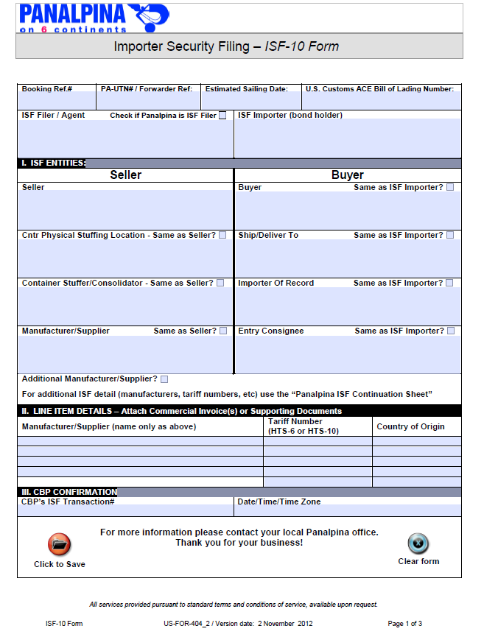

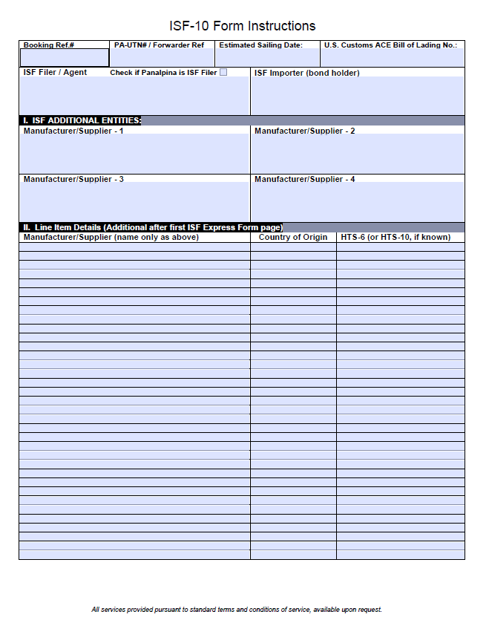

**F.O.B. TERMS FOR DOMESTIC SHIPMENTS**

1. F.O.B. DESTINATION, FREIGHT COLLECT or
2. F.O.B. ORIGIN, FREIGHT COLLECT
3. Prepaid and add must be approved by Logistics.

DOMESTIC SHIPPING TERMS

###### F.O.B. origin, freight prepaid F.O.B. origin, freight collect (NASSCO PREFERRED)

**Buyer pays freight charges**

**Buyer bears freight charges**

**Buyer owns goods in transit**

**Buyer files any claims**

**Seller pays freight charges**

**Seller bears freight charges**

**Buyer owns goods in transit**

**Buyer files any claims**

###### F.O.B. origin, freight prepaid and add F.O.B. destination freight collect (NASSCO 2ND PREFERRED)

**Buyer pays freight charges**

**Buyer bears freight charges**

**Seller owns goods in transit**

**Seller files any claims**

**Seller pays freight charges**

**Buyer bears freight charges**

**Buyer owns goods in transit**

###### Buyer files any claims

**F.O.B. destination, freight prepaid F.O.B. destination freight collect and allowed**

**Buyer pays freight charges**

**Seller bears freight charges**

**Seller owns goods in transit**

**Seller files any claims**

**Seller pays freight charges**

**Seller bears freight charges**

**Seller owns goods in transit**

**Seller files any claims**

**Incoterms FOR INTERNATIONAL SHIPMENTS**

* **Use INCOTERMS 2000/ INCOTERMS 2010.**
* **You must specify which INCOTERMS is used(2000/2010): i.e “FAS as per INCOTERMS 2010” or “DDU as per INCOTERMS 2000”**
* **Each PO will provide correct terms, i.e. DDU, NASSCO, SAN DIEGO**
* **Published by ICC Publishing, 156 Fifth Ave. New York, NY 10010**

**(ICC Publication No. 560)**

**INTERNATIONAL SHIPPING TERMS**

|  |  |  |  |  |  |  |  |  |  |  |  |  |  |
| --- | --- | --- | --- | --- | --- | --- | --- | --- | --- | --- | --- | --- | --- |
| Regardless of the Incoterms in use, the seller must supply the goods as agreed in the contract of sale, together with such evidence of conformity as may be required by the contract. | | | | | | | | | | | | | |
| Regardless of the Incoterms in use, the buyer must take receipt and pay for the goods delivered, as provided in the contract. | | | | | | | | | | | | | |
| The payment of the forwarding fee is sometimes controversial, depending on the contract of sale. | | | | | | | | | | | | | |
| \*\* Risk of loss or damage is transferred from seller to buyer when goods have been delivered to carrier. | | | | | | | | | | | | | |
|  |  |  |  |  |  |  |  |  |  |  |  |  |  |
| **Carriage Paid To**: The seller pays the freight to the named destination. | | | | | | | | **DAT (Delivered At Terminal) New Term 2010:**  Seller delivers when the goods, once unloaded from the arriving means of transport, are placed at the disposal of the buyer at a named terminal at the named port or place of destination. "Terminal" includes quay, warehouse, container yard or road, rail or air terminal. Both parties should agree the terminal and if possible a point within the terminal at which point the risks will transfer from the seller to the buyer of the goods. If it is intended that the seller is to bear all the costs and responsibilities from the terminal to another point, DAP or DDP may apply. | | | | | |
| **Carriage & Insurance Paid**: Same as CPT plus cargo insurance. | | | | | | | | **Delivered ex Ship**: Take possession at the port of arrival, on the ship, uncleared. | | | | | |
| **Cost, Insurance, & Freight**: Same as CFR plus insurance. | | | | | | | | **Delivered ex Quay (duty paid)**: Ownership changes on the wharf after entry has been made and duty paid. | | | | | |
| **Cost and Freight**: The seller must pay the cost and freight necessary to bring the goods to the port of destination, not including insurance. The goods must be cleared for export. | | | | | | | | **Delivered Duty Unpaid**: Seller is responsible for all transportation charges except custom duties and taxes abroad. | | | | | |
| **Ex Works:**  The buyer is obligated to pick the goods up from the seller at his dock and move the goods as well as pay all charges from that point forward. | | | | | | | | **Delivered Duty Paid**: Seller is responsible for all charges including duty, taxes and delivery at destination. | | | | | |
| **Free on Board**: Seller is obligated to have the goods packaged and ready for shipment from the agreed point. The buyer normally assumes the burden of all inland transportation costs and risks in the exporting country, as well as all subsequent transportation costs, including the costs of loading the merchandise on the vessel. Seller fulfills his obligation to deliver when the goods have passed over the ship's rail at the named port of shipment. | | | | | | | | **Free Alongside Ship:** The seller fulfills his obligation to deliver when the goods have been placed alongside the vessel, on the quay, or in lighters at the named port of shipment. | | | | | |
| **Delivered At Place (named destination place) New Term 2010:**  Seller delivers the goods when they are placed at the disposal of the buyer on the arriving means of transport ready for unloading at the named place of destination. Parties are advised to specify as clearly as possible the point within the agreed place of destination, because risks transfer at this point from seller to buyer. If the seller is responsible for clearing the goods, paying duties etc., consideration should be given to using the DDP term | | | | | | | | **Free Carrier:** The seller fulfills his obligation to deliver when he has handed over the goods, cleared for export, into the charge of the carrier named by the buyer at the named place or point. | | | | | |

**INCOTERMS 2000 & INCOTERMS 2010 CHARTS BELOW**

**INCOTERMS 2000**

|  |  |  |  |  |  |  |  |  |  |  |  |  |  |
| --- | --- | --- | --- | --- | --- | --- | --- | --- | --- | --- | --- | --- | --- |
| **INCOTERMS and Services** | **EXW** | **FCA** | **FAS** | **FOB** | **CFR** | **CIF** | **CPT\*\*** | **CIP\*\*** | **DAF** | **DES** | **DEQ** | **DDU** | **DDP** |
|  | Ex Works | Free Carrier | Free Alongside Ship | Free on Board | Cost and Freight | Cost, Insurance, & Freight | Carriage Paid To | Carriage & Insurance Paid | Delivered at Frontier | Delivered ex Ship | Delivered ex Quay (duty paid) | Delivered Duty Unpaid | Delivered Duty Paid |
|  | named place | named place | named port of destination | named port of destination | named place of destination | named place of destination | named place of destination | named port of destination | named place | named port of destination | named port of destination | named place of destination | named port of destination |
| warehouse storage at point of origin | SELLER | SELLER | SELLER | SELLER | SELLER | SELLER | SELLER | SELLER | SELLER | SELLER | SELLER | SELLER | SELLER |
| warehouse labor charge at origin | SELLER | SELLER | SELLER | SELLER | SELLER | SELLER | SELLER | SELLER | SELLER | SELLER | SELLER | SELLER | SELLER |
| export packing | SELLER | SELLER | SELLER | SELLER | SELLER | SELLER | SELLER | SELLER | SELLER | SELLER | SELLER | SELLER | SELLER |
| loading at point of origin | BUYER | SELLER | SELLER | SELLER | SELLER | SELLER | SELLER | SELLER | SELLER | SELLER | SELLER | SELLER | SELLER |
| inland freight | BUYER | BUYER | SELLER | SELLER | SELLER | SELLER | SELLER | SELLER | SELLER | SELLER | SELLER | SELLER | SELLER |
| port receiving charges | BUYER | BUYER | SELLER | SELLER | SELLER | SELLER | SELLER | SELLER | SELLER | SELLER | SELLER | SELLER | SELLER |
| forwarding fees | BUYER | BUYER | SELLER | SELLER | SELLER | SELLER | SELLER | SELLER | SELLER | SELLER | SELLER | SELLER | SELLER |
| loading on ocean carrier | BUYER | BUYER | BUYER | SELLER | SELLER | SELLER | SELLER | SELLER | SELLER | SELLER | SELLER | SELLER | SELLER |
| ocean freight | BUYER | BUYER | BUYER | BUYER | SELLER | SELLER | SELLER | SELLER | SELLER | SELLER | SELLER | SELLER | SELLER |
| charges in foreign port | BUYER | BUYER | BUYER | BUYER | BUYER | BUYER | SELLER | SELLER | SELLER | BUYER | SELLER | SELLER | SELLER |
| delivery charges to final destination | BUYER | BUYER | BUYER | BUYER | BUYER | BUYER | BUYER | BUYER | BUYER | BUYER | BUYER | SELLER | SELLER |
| customs duties and taxes abroad | BUYER | BUYER | BUYER | BUYER | BUYER | BUYER | BUYER | BUYER | BUYER | BUYER | SELLER | BUYER | SELLER |

**FCA, FAS foreign supplier/port is preferred**

**DDU to be approved by GD NASSCO Purchasing/Logistics**

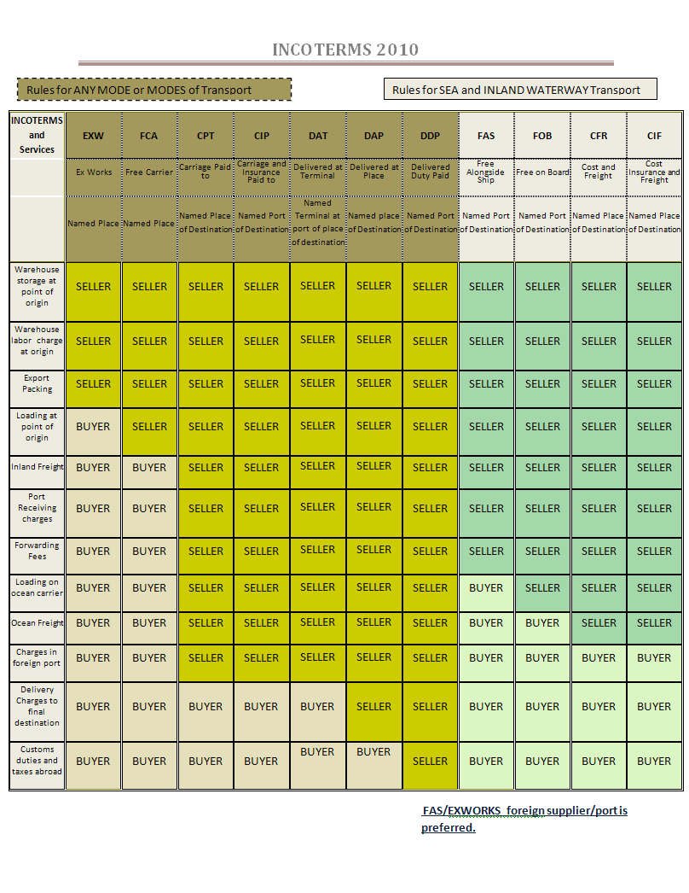

Packaging Standards

|  |  |
| --- | --- |
| 1. Purpose and Scope: The purpose of this guideline is to suggest improved packaging practices to better protect supplies and equipment from damage in transit to and residing at General Dynamics NASSCO warehouses and shipyard. These practices are not contractual. They address generic packing methodologies for safe handling of the product, safety of the people handling packaged items, and storage periods for a minimum of 1 year in enclosed facilities without damage to the supplies and equipment. For further general guidance, refer to ASTM Designation: D 3951 – 95 (by Reference). Please also refer to Title 49 of the Code of Federal Regulations for packaging requirements excluding hazardous materials, explosives, or ammunition. 2. Transportation of Cargo: The proper blocking and bracing of crates, pallets and skidded items into a cargo container for transport is paramount to the product arriving in a safe condition. The packaged freight should be blocked, braced and strapped to prevent movement in 3 different directions: laterally (side to side), longitudinally (end to end) and vertically (up and down). The use of wood blocking, metal banding, buttress blocking and dunnage bags to secure the freight inside the container is required. 3. Container Markings: Markings must include the name and address of both consignee and consignor, as well as any other relevant precautionary markings. Containers should clearly identify the dimensions, gross weight, if significantly off balance mark center of gravity, and lifting points. All markings signifying contents of the package should be apparent and durable. In addition, crates must be “ISMP-15” compliant. 4. Crates, Boxes, Pallets and Skids: To ensure longer lasting durability, it is preferable that crates are held together by the use of screws and bolts. There should be a minimum of 2” clearing space within the crate. Enclosed products must be easily accessible for inspection, removal, storage, and maintenance. 5. Base: The base of the Crate, Skid, or Pallet should extend by a minimum of 2” to 3” on each side beyond the widest packaged equipment. At no time shall the materials or equipment extend beyond the base. The major factor in determining the base design is the weight of the item. 6. All pallets should have stringers and clearly marked strapping points. 7. Styles:  * Standard pallet * Skid with 2” nominal deck boards * Load Bearing Members (LBMs) should be utilized to ensure the equipment does not break through the base. Placement of LBMs should be placed directly under the weight distribution points.  1. Securing: Items need to be prevented from movement in 3 different directions: laterally (side to side), longitudinally (end to end) and vertically (up and down). 2. Cushioning: To protect against shock and vibration, where mechanical items could move within the crate, cushioning is required.   Securing/cushioning methods:   * Blocking and Bracing: Adding wooden blocks to the inside of the container to stop movement. * Foam and Confinement: The process of encasing an item in a cavity with foam by lining the interior of the container. * Bolting and Lagging: Using threaded hardware to secure an item through its mounting brackets or the base of the container. * Banding or Bridging: The process of using metal or plastic bands and wooden bridges over the top to secure the load to the base of the container. * Cushioning using bubble wrap, dunnage bags, or foam is acceptable. * Peanuts, straw, and newspaper are NOT permitted. * Equipment with sheet metal casing (switchboards, etc.,) must have corner protection to avoid damage from strapping. * Multiple boxes on pallets should be shrink-wrapped, individually marked and banded to the pallet. * Exposed knobs, handles, and switches should be protected from accidental damage. However, protection must be easily removed and capable of re-installation. Foam protection should be used regarding meters, gauges, and displays – removable and replaceable as required. * All valves should have protection around the flange face. * All gauges, drain plugs, terminals, exposed piping and tubing should also be protected.  1. Unitization:  * Multiple purchase orders must be packaged separately. * Loose parts should not be packed within the equipment (i.e., Storing small parts in switchboard cabinets) * Loose parts must be individually packaged and clearly marked. Please refer to purchase order instructions. * Only Loose Parts marked with an “EL” prefaced part number may be shipped separately. All other parts must be shipped fully assembled. * Bulk packaging is specifically excluded unless specified in the contract or order.  1. In general, General Dynamics NASSCO reserves the right to refuse shipments that are not palletized, adequately protected, and capable of multiple handling with lift equipment. Suppliers are encouraged to use advanced packaging techniques with suppliers of your choice. An example is Craters & Freighters; see contact info below:   Craters & Freighters  6500 Federal Blvd.  Lemon Grove, CA 91945  Local: 619-265-0509  Toll free 888.380.SHIP (7447)  Keith.b@cratersandfreighters.com  www.cratersandfreighterssandiego.com | misc 4 008 copy  cribbing crate2  Correct securing in all 3 axis.  C:\Documents and Settings\Keith\Local Settings\Temporary Internet Files\Content.Outlook\CUJR2C45\DSC01140.JPG  Correct Markings: Length, Width, Height, Weight, Ship From info, Ship To info, Packing list, Lift points. See the above center of gravity ISPM 15 Stamp.  Barrier_Bag_Bumper_Cushioning  See above for a correct example of proper crate construction – note clearance.  NASSCO Incorrect.JPG  See the above example of pallet deficiencies.   * Product extends past the skid * Control box is not secured and bubble wrapped * No stringers on the bottom of the skid * No blocking or bolting of the unit * No markings on where to lift (Center of Gravity)   NASSCO Correct.JPG  See above for an example of a correct pallet.   * The skid extends beyond the outside dimensions of the product * Control box is secured and wrapped appropriately * Stringers are on the bottom of the skid * The unit is blocked, bolted and secured properly   crate 3  See above for a correct example of proper blocking inside crate for a pump.  Y:\Craters And Freighters Pictures\DSC00947.JPG  See above for a correct example of proper cushioning and internal spacing inside of a box or crate.  **PIC 5**  See above for a correct example of proper protection for a coupling or gauge.  cid:image003.jpg@01CA907D.4549B2D0 |