# INTRODUCTION

Being around energy is an everyday part of our lives, and an important part of our workplace operations. High pressure steam, electricity, hydraulic and pneumatic systems, even the force of gravity are common forms of energy used to power our machines and processes. The same reasons that make energy useful also make it dangerous. Understanding how to properly control hazardous energy is one of the keys to workplace safety.

This training covers Lockout-Tag Plus procedures and NASSCO’s Lockout-Tag Plus system. You will learn about types of energy sources, key definitions, the energy control plan, lockout/tagout devices, Lockout-tag plus on US Navy ships undergoing repair and special lockout situations.

# TIPS FOR PRESENTING THIS MATERIAL

* Read the material before you present it.
* If possible, go to machinery (valve, pump, motor, electrical panel etc.) in your work area and walk through a lockout-Tag Plus with employees. Don’t assume all employees know the proper procedure.
* Copy the attached quiz for all employees to take at the end of the training. Don’t hand out the answers by mistake!
* Make sure all employees sign your training roster. Please attach a copy to your Tier 3 documents.

Encourage your employees to get involved during training by asking questions as suggested in this material, or in other ways you think are appropriate. The more they are involved, the more they’ll remember. Some ways to get your employees involved could be:

* Ask them to answer questions out loud.
* Ask them to share stories about themselves or co‐workers related to Lockout Tag Plus procedures such as incidents or close calls.

# TYPES OF ENERGY SOURCES

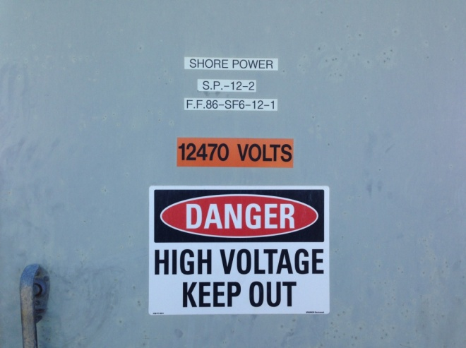Types of energy sources include electrical, mechanical, chemical, thermal, and gravity. No matter its source, energy must be harnessed and controlled in order to safely perform work.

The types of energy can be divided into two states.

* **Kinetic energy** – Kinetic energy is the energy of motion. An object that has motion has kinetic energy.
* **Potential energy** – Potential energy is stored energy. Some examples are: compressed spring, drawn bow, or a car parked on an incline street. Energy can be:
  + Electrical – when current runs through wires or cables.
  + Hydraulic – compressive force or movement of a liquid in a pipe or hose.
  + Pneumatic – power created by the compressive force or movement of air or gas in a confined area like a hose or pipe.
  + Gravity – a force which can cause a machine to cycle or a piece of equipment to fall. A good example would be working underneath an elevator cab. (Lockout is required to prevent the elevator from dropping.)
  + Mechanical – mechanical energy is the ability to do work. Any object that possesses mechanical energy, whether it is in the form of potential energy or kinetic energy, is able to do work. 
  + Chemical – chemical energy is energy stored in the bonds of chemical compounds (atoms and molecules). Chemical energy is released in a chemical reaction, in the form of heat.

# THE ENERGY CONTROL PLAN

NASSCO work instructions comply with 29 CFR 1915.89, Control of Hazardous Energy (lockout/Tag-plus). They include the following:

* Safety Procedure Manual, Work Instruction 305, Lockout, Tagout and TagPlus Procedures
* Safety Procedure Manual, Work Instruction 336, Lockout/Tags-plus Requirements for Facilities, Maintenance and Temporary Services Applications
* Test & Trials Manual, Work Instruction 103, Electrical and Mechanical Tag-Out Program

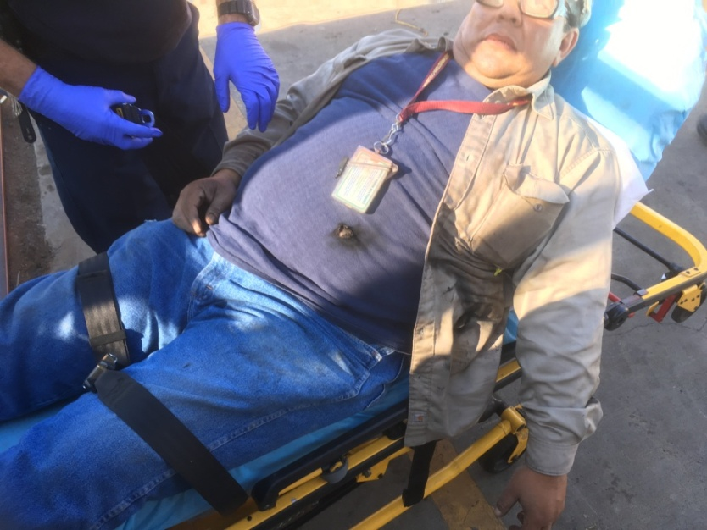These work instructions are established to help prevent injuries from the unexpected release of energy. They include employee training and verification of energy isolation before starting work.

# TAG ORIGINATOR, TRADE AUTHORIZED AND AFFECTED EMPLOYEES

Employees are designated as either tag originator, authorized employees, or affected employees for lockout/tagout operations. Each designation carries differing roles and responsibilities.

**Authorized Employee: Authorized employees are broken into two categories:**

* **Trade Authorized Employee:** Any employee who performs servicing activities on machinery, equipment, or systems, and is being protected by a Lockout or Tags-plus system. Trade Authorized Employees are not authorized to perform isolation tasks, hang tags, or apply locks. Trade Authorized Employees must know:
  + The reasons for the Hazardous Energy Control Procedures and what they are used for;
  + The prohibition against restarting or reenergizing machines or equipment which are locked out or tagged out; and
  + The hazards of their work when performed under lock/out and tag/out conditions

Trade Authorized Employees must be notified before lockout/tagout operations are begun and informed which machines or equipment will be shut down and locked out.

* **Tag Originator:** Employees who have the training, knowledge, and experience associating with the machinery, equipment, or system being worked, the hazards associated with the release of hazardous energy, means to control these hazards, and are qualified to identify the hazard, apply lockout/tags-plus devices, verify isolation/de-energization, and ensure the safe exposure status for Trade Authorized Employees. Tag Originators are authorized to remove tags and isolation devices when work is complete.
  + In a group system, one Tag Originator shall be responsible for applying primary lockout devices and tags, monitoring the safe exposure status of all employees servicing the machinery, equipment, or system, and coordinating the application or removal of the system with the appropriate lockout/tags-plus Coordinator/Qualified Supervisor.

**The Tag Originator is a qualified person who locks out or tags out specific machines or equipment** so that cleaning, repairing, servicing, setting-up, adjusting or unjamming operations can be conducted. These employees are trained:

* + To know the potential hazards of jobs and have the knowledge and skills necessary for the safe usage of the specific Hazardous Energy Control Procedures for each machine, piece of equipment or prime mover they are responsible for.
  + The same individual may be both a Tag Originator and Trade Authorized Employee.
* **Affected Employee:** Those who normally operate or use the machinery, equipment, or system that is going to be serviced under lockout/tags-plus or who are working in the area where servicing is being performed under lockout/tags-plus. Affected employees do not work directly on servicing operations. They are not trained to apply or remove lockout/tagout devices.

Affected employees must be able to recognize when a lock-out procedure is in progress. They are not to bypass, ignore or defeat any lockout/tags plus system.

# LOCKOUT/TAGOUT DEVICES

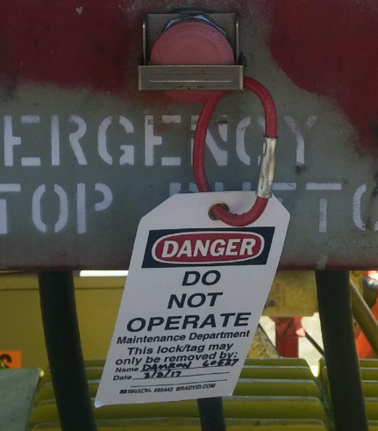Any time a lockout/tagout procedure is performed, some type of lockout device is needed. These devices come in a wide variety of types and styles. Some examples are locks, chains, wedges, and locking valve covers or self-locking fasteners. Although they may look different, their purpose is the same: to isolate, secure, or block the machine or equipment from its energy source.

These devices are substantial enough that they cannot be easily removed without excessive force, such as with bolt cutters. Lockout and tagout devices need to be able to withstand the environment to which they are exposed for the duration of the lockout.

Tagout devices, including their means of attachment, shall be substantial enough to prevent inadvertent or accidental removal. Attachment devices are required to be of a non-reusable type, attachable by hand and self-locking. They must be able to withstand 50 pounds of force. The print and format of the tag is standardized to be recognizable.

Information contained on a tag is valuable, especially in the event of an emergency. While the tag must indicate the identity of the employee applying it, it can also specify the department they work in, the date the work began and when it is expected to be completed.

In addition, tags must provide specific instruction to prevent energization of machines or equipment under lockout/tagout condition. Some of these warnings are “Do Not Operate,” “Do Not Start,” “Do Not Open Valve,” “Do Not Close,” and “Do Not Energize.”

Lockout/tagout devices must not be used for any other purposes. Using lockout or tagout devices for other uses may cause confusion and reduce their effectiveness as a safety device.

# TAG PLUS SYSTEM

If an energy-isolating device is not capable of being locked, a tags-plus system is used to prevent re-energizing or startup, or the release of hazardous energy, before any servicing is started.

When a system cannot be locked, always hang your tag in addition to other measures such as pulling fuses. If the system can be locked lock it!

This means that using just tags to isolate a switch or breaker is not enough. In all cases when locks cannot be used, additional measures must be implemented when working with hazardous energy.

# LOCKOUT-TAG PLUS ON US NAVY SHIPS UNDERGOING REPAIR

When performing lockout/tagout on a U.S. Navy repair ship, the tag originator must contact the Ship’s representative to initiate the tagout process before work can begin.

* The US Navy ship’s representative will position the tag stating the name of the person requesting the tag, the date issued, and the system or equipment that is to be worked on.
* The tag is signed by the tag originator who requested it, the US Navy division officer, and the person in charge of the tag‐out log.
* The name of the tag originator’s employer is printed on the tag near the tag originator’s signature even though there is no specific blank for the company’s name.
* The tags are attached to points in the system such as valves, breakers, or switches that control the energy to the equipment.
* After the system is tagged out the tag originator must confirm that the system is de-energized before assigning work.
* During the work, frequent tests must be made by all authorized employees working on the system to ensure that energy has remained secured.
* Prior to re-energizing the system the tag originator must confirm that all work is complete and employees are off the system.
* To remove a tag, the process is followed in reverse.

When working onboard in New Construction, use NASSCO’s Test and Trials Electrical and Mechanical Tag‐Out Program Work Instruction No.: 103. Contact the Lockout-Tag Plus Coordinator assigned to the ship.

# SPECIAL SITUATIONS

There are certain lockout situations which require special consideration. The three most common are *group lockout*, *during shift changes*, and when *outside contractors are working on NASSCO facilities.* These circumstances are challenging because they involve multiple employees working on a system. Clear communication is vital to ensure the safety of all.

During a *group lockout*, primary responsibility for the lockout will be given to a designated authorized person (tag originator), who will be able to ascertain the exposure status of the individual members under him/her. Each person involved has his or her own lock and tag and must place it either on the energy control device, as in the case of a multiple lock hasp, or onto a lock box. Each employee is responsible for removing his or her lock and tag when they stop working on the machinery or piece of equipment. This ensures that all personnel are accounted for and out of danger before the machine is re-energized.

During a *shift change*, the departing workers must not remove their locks until the arriving workers attach theirs.

In the event a lockout device must be removed and the person who installed it cannot be located after making reasonable efforts to contact him/her, only a NASSCO lockout/tagout Coordinator/Qualified Supervisor may authorize the lock be removed. When the employee returns to work at the facility, they must be notified as to what occurred.

*Outside personnel servicing equipment* are to be trained in lockout/tagout by their employer. Outside contractors must work under NASSCO initiated lockout/tagout system. Outside personnel (i.e. non-NASSCO personnel) are not authorized to perform shutdown of the machinery, equipment or system.

Each piece of equipment is different and may not always be easily accessible. When locking out equipment that is out of sight of its control panel, a coworker must help when testing the effectiveness of the lockout.

Finally, if you are unsure how to perform a proper lockout under certain conditions or on a particular piece of equipment, don’t do it. Check the written plan or consult your supervisor.

# LOCKOUT/TAG PLUS REVIEW

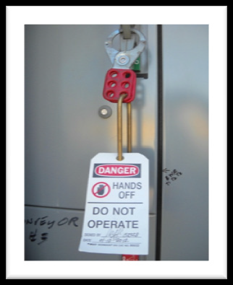Follow these steps to a safe lockout:

1. Know what types of energy the machine uses. Find the switches, valves or other devices that need to be locked out.
2. Let other employees know that you’ll be locking or tagging out the equipment.
3. Turn off the machine or equipment.
4. Locate and isolate all energy sources. Release of any stored energy, as in springs, hydraulic systems or air pressure. Be sure there’s nothing left to move a machine part. Don’t forget about gravity!
5. Lockout the switches or other energy controls. Attach a lock that holds them in an “off” or “safe” position.
6. Test controls to ensure they do not activate the machine. Then return the **controls** to the “off” position.
7. Perform your maintenance or repair.

Tags warn others that the equipment is being worked on and that they are not to change the position of the equipment on which the tag is hung. Equipment tags are typically placed on power panels, power switches, distribution boxes, valves and control valves. Most of us will never initiate a Lockout Tag Plus. So it’s important to know one thing … if you see a tag do not remove it or use what it is attached to.

# LOOKOUT/TAGOUT *REVIEW QUIZ*

1. An energy source that is in the process of actively doing its work is known as ______________ energy.

a) potential b) kinetic c) controlled

1. Only authorized and affected employees are permitted to perform lockout procedures and maintenance on energized equipment.
   * + 1. True b) false
2. You may use the lock that you use on your tool box to lockout equipment that you are going to service/repair
   * + 1. True b) false
3. Tags must be attached securely enough to withstand _______________ pounds of force.
   * + 1. 5 b) 50 c) 500
4. What is the first step to take for returning equipment to service after repair work has been completed?
5. remove locks and tags from the equipment
6. inform affected employees the work has been completed
7. remove all tools and materials from the immediate area
8. Tags can be used more than once.
9. True b) False
10. Only authorized employees may remove a lockout device that must be removed when the person who installed it cannot be located.
11. True B) False

***ANSWERS TO THE REVIEW QUESTIONS***

1. b

2. b

3. a

4. b

5. c

6. b

7. b